Ex.N.3: Spectrum Analysis of Sub-1 GHz, Mid-band & mmWave by Plotting Propagation Loss. Date
AIM:
To analyze the propagation loss characteristics of different frequency bands (Sub-1 GHz, Mid band, and mmWave) in wireless communication systems and compare their performance over varying distances using MATLAB.
Procedure
1. Define frequency bands: Sub-1 GHz (0.9 GHz), Mid-band (3.5 GHz), and mmWave (28 GHz).
2. Set communication distance range (e.g., 0.1 km to 5 km).
3. Use Free Space Path Loss (FSPL) formula to compute propagation loss: PL(dB)=20log⁡10(d)+20log⁡10(f)+32.44
4. Calculate propagation loss for each frequency band over varying distances. 5. Plot distance vs propagation loss curves for comparison.
6. Analyze how higher frequencies experience higher attenuation.
7. Compare coverage efficiency of each spectrum band.
8. Display results using MATLAB plots.
Objective 1: Matlab Code and Output:
clc;
clear;
close all;
d = 0.1:0.1:5;
f = [900 3500 28000];
PL1 = 32.44 + 20*log10(f(1)) + 20*log10(d);
PL2 = 32.44 + 20*log10(f(2)) + 20*log10(d);
PL3 = 32.44 + 20*log10(f(3)) + 20*log10(d);
figure
subplot(2,1,1)
plot(d,PL1,'b','LineWidth',2); hold on
plot(d,PL2,'r','LineWidth',2)
plot(d,PL3,'k','LineWidth',2)
title('Propagation Loss vs Distance')
xlabel('Distance (km)')
ylabel('Loss (dB)')
grid on
subplot(2,1,2)
Freq = [900 3500 28000];
Loss = [PL1(10) PL2(10) PL3(10)];
plot(Freq,Loss,'-o','LineWidth',2)
title('Propagation Loss vs Frequency')
xlabel('Frequency (MHz)')
ylabel('Loss (dB)')
grid on
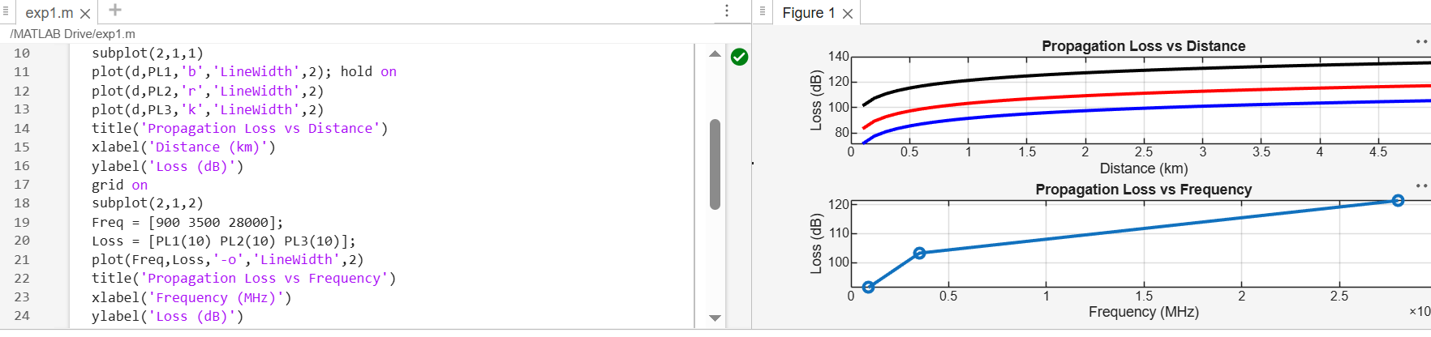
Objective 2: Matlab Code and Output:
clc;
clear;
close all;
d = 2; % fixed distance (km)
f = [900 3500 28000]; % MHz
PL = 32.44 + 20*log10(f) + 20*log10(d);
figure
% -------- Graph 1: Frequency vs Loss --------
subplot(2,1,1)
plot(f,PL,'-o','LineWidth',2)
title('Propagation Loss vs Operating Frequency')
xlabel('Frequency (MHz)')
ylabel('Propagation Loss (dB)')
grid on
% -------- Graph 2: Band Comparison --------
subplot(2,1,2)
bar(PL)
title('Comparison of Propagation Loss Across Bands')
xlabel('Frequency Bands (Index: 1=Sub-1GHz, 2=Mid-band, 3=mmWave)') ylabel('Propagation Loss (dB)')
xticklabels({'Sub-1GHz','Mid-band','mmWave'})
grid on
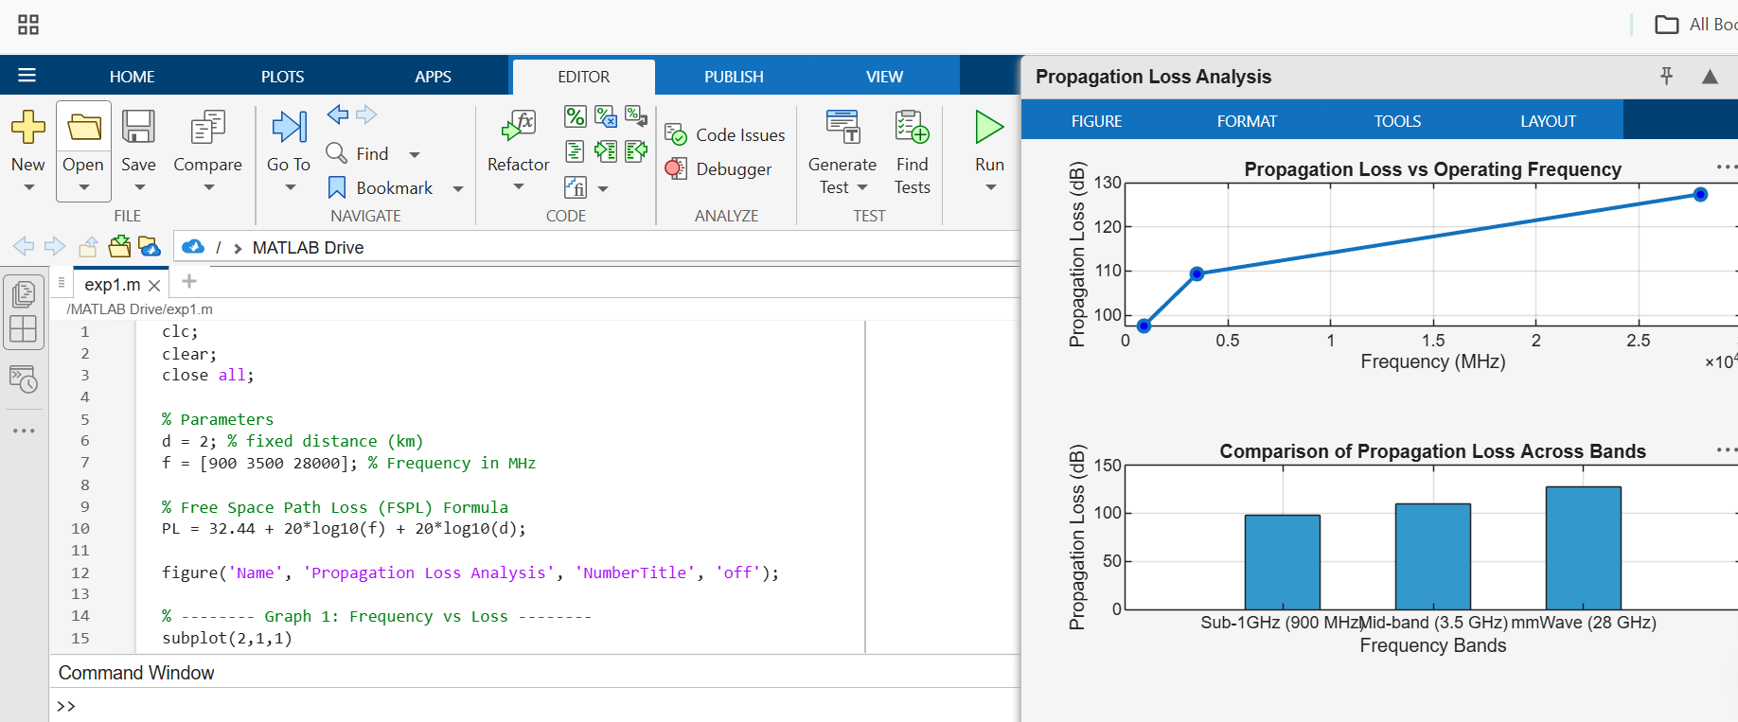
Objective 3: Matlab Code and Output:
clc; clear; close all;
% Frequency bands (MHz)
f = [900 3500 28000];
% Distance (km)
d = 2;
% Propagation Loss (FSPL)
PL = 32.44 + 20*log10(f) + 20*log10(d);
figure
% -------- Graph 1: Simple Line Plot (SAFE) --------
subplot(2,1,1)
plot(f, PL, '-o', 'LineWidth', 2)
title('Propagation Loss vs Operating Frequency')
xlabel('Frequency (MHz)')
ylabel('Propagation Loss (dB)')
grid on
% -------- Graph 2: Safe Comparison Plot --------
subplot(2,1,2)
plot(1:3, PL, '-s', 'LineWidth', 2)
title('Band-wise Propagation Loss Comparison')
xlabel('Band Index (1=Sub1GHz, 2=Mid-band, 3=mmWave)')
ylabel('Propagation Loss (dB)')
grid on
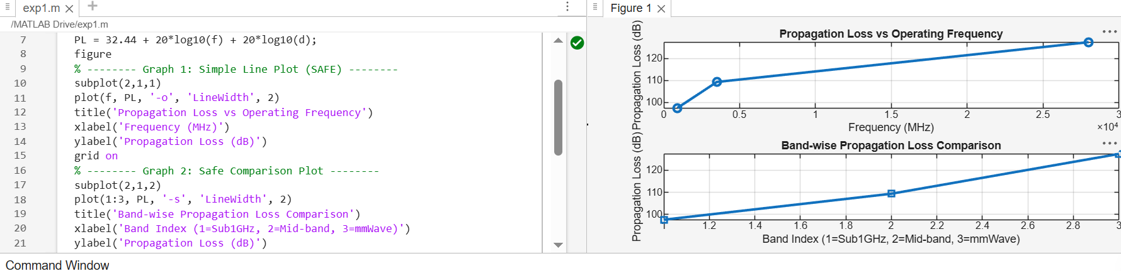
Result:
1. The propagation loss was successfully computed for Sub-1 GHz, Mid-band, and mmWave frequency bands using the Free Space Path Loss (FSPL) model.
2. It was observed that propagation loss increases with increase in operating frequency, with mmWave showing the highest attenuation and Sub-1 GHz showing the lowest loss.
3. The comparative analysis of spectrum bands clearly demonstrates that lower frequency bands are more suitable for long-range communication, while higher frequency bands require advanced techniques like beamforming for efficient performance.

